What is Collaborative Communication and Ecomaps

Collaborative Communication is a communication process that focuses on three aspects of communication:
- Self-empathy (defined as an awareness of one's own inner experience)
- Empathy (defined as an understanding what we see in the other person)
- Honest self-expression (defined as expressing oneself authentically in a way that is likely to inspire compassion in others).

Collaborative Communication aims to find a way for all present to identify what really matters to them without the use of guilt, humiliation or shame. It is useful for resolving conflicts, connecting with others, and working in a way that is conscious, present, and attuned to the genuine, living and working needs of all parties.

Students and teachers should be helped to develop their emotional literacy and identify their emotions and reasons for actions in terms of satisfied and unsatisfied needs. This can form a large part of circle time in class and staff development meetings with colleagues. Collaborative communication aligns closely with Iben Sandahls Cognitive Diamond.

The Practice of Collaborative Communication

Collaborative Communication is a simple method for clear, empathic communication consisting of four steps:

- Stating observations
- Recognising and expressing feelings
- Identifying needs
- Making realistic and achievable requests.

1. Stating Observations
During the first phase on collaborative communication it is essential that we elicit from the other party or state (children, parents or colleagues) the observations that we have made which led to the conflict, complaint or grievance. These should be purely factual observations, with no component of judgment or evaluation. The stating of factual observations should be used to elicit communication in all professional discourse, including:

- Conflict Resolution
- Grievance Resolution
- Performance Management
- Lesson Observations

Teacher
For example, “I noticed that you didn’t write a learning objective on the board” states an observed fact, while “It’s school policy to write a learning objective on the board and it’s something you have to do” makes an evaluation and denies the other party ownership of his or her own actions. There may well be an excellent reason for not stating the learning objective and the opportunity to discuss the reason may be lost when evaluations or value judgments are made.

Student
For example, “I noticed that you pushed Sarah in the corridor” states an observation of fact. “You must not push people as it is unacceptable behaviour” makes an evaluation.

2. Recognising and Expressing Feelings
The second phase requires a statement of the feeling that the observation is triggering in us, or guess what the other person is feeling, and ask. Naming the emotion, without moral judgment, enables us to connect in a spirit of mutual respect and cooperation. We should perform this step with the aim of accurately identifying the feeling that we or the other person is experiencing in that moment, not with the aim of shaming them for their feeling or otherwise trying to prevent them from feeling as they do.

Teacher
For example, "I noticed that you were shaking your head throughout the staff meeting (observation). Were you angry?"

Student
“I noticed that you shouted at John. Were you frustrated”?

We should try to avoid giving reasons for the perceived emotion. We simply state the observation and guess the emotion. It would be less conducive to open, collaborative communication if we were to ask the other party if we were the cause of his or her anger.

3. Identifying Needs
In phase 3, we try to identify the need(s) that is the cause of that feeling. Or, guess the need that caused the feeling in the other person, and ask. When our needs are met, we have happy, positive feelings; when they are not met, we have negative feelings. By tuning into the feeling, we can often find the underlying need. Stating the need, without morally judging it, gives both parties clarity about what is really driving the emotion at that time.

Teacher
Manager: | You were shaking your head throughout the meeting (Observation). Were you angry? (Perceived emotion)
Teacher: | Yes, I was. You didn’t give me time to say what I wanted. I felt that I was misunderstood and not given the opportunity to explain myself.
Manager: | I’m sorry that you felt that way, but I had a lot of other teachers that wanted to speak. I moved the meeting on so as to give as many people a chance to speak as possible (Observation). While you were shaking your head, I felt uncomfortable and afraid that others would perceive me as being disrespected (emotion). It seems to me that you need to be listened to more carefully and understood in what it is you want to say, while I need to feel that I have the attention and respect of staff members while chairing a meeting. (Identifying needs) So, how can we ensure that in future we both have these needs met? (Seeking realistic solutions)

In far too many cases, the Manager would feel compelled to react as follows:

“I just want to let you know that your behaviour during today’s meeting was totally unacceptable. You made me look weak in the presence of colleagues and you showed me absolutely no respect. You may take this as a verbal warning and I do not expect to see any repetition of this behaviour. I would like you to go away, think carefully about your attitude and start acting like a professional teacher.”

4. Making realistic and achievable requests.
In phase 4 we should try to form a concrete request for action to meet the need(s) just identified. We should ask clearly and specifically for what we want right now, rather than hinting or stating only what we don't want.

Manager: | Why don’t we meet later to discuss your ideas in more detail? (Request)
Teacher: | That would be great. And could we look at ways of providing open feedback on staff meetings so that we can discuss issues in more depth. (Request)
Manager: | Fine! Let’s meet later and brainstorm ways in which we can improve communication generally and hopefully that will allow us to continue running meetings at a high pace.

In this way, a member of staff has moved his or her position from one of perceived defiance or disrespect to that of a valued contributor to school development.

For the request to really be a request, and not a demand, we should allow the other person to say no or propose an alternative. We take responsibility for getting our own needs, and those of the school, met, and we let the other person take responsibility for theirs.

When we do something together, we want it to be because we both voluntarily consent to it, as a way of fulfilling our own genuine needs and desires, not out of guilt or pressure. Sometimes we can find an action that meets both our needs, and sometimes we may have no choice but to agree to disagree and/or initiate formal grievance or disciplinary procedures.

Tips

As simple as Collaborative Communication is, it can be much harder to put into practice than it looks. We recommend that senior and middle managers;

- Read Marshall Rosenberg's book; Non Violent Communication, a Language of Life. http://www.slideshare.net/nonviolent/nonviolent-communication-a-language-of-life-full-book

- Watch the San Francisco Workshop - Marshall Rosenberg. https://www.youtube.com/watch?v=YwXH4hNfgPg

- Try it out in practice, make mistakes, see what went wrong, and try out what has been learned next time. In time, it flows naturally.

Things to Avoid

Avoid saying "You made me feel ____", "I feel ____ because you did ____," and especially, "You're making me angry." These put responsibility for our feelings on the other person, and they avoid identifying the need that is the true cause of your feeling.

An alternative: "When you did ____, I felt ____ because I needed ____." Explicit phrasing is communicating our needs without making one person responsible for another person's feelings and makes it unnecessary to spell things out too fully.

We might not always guess what someone is actually feeling or needing when empathizing. The fact that we are listening and want to understand, without criticizing or judging or analysing or advising or arguing, will quite often lead people to open up more so that we have a better or different sense of what is going on. Genuine interest in the feelings and needs that are driving each other's actions will lead us someplace new, someplace that we cannot predict before we have that understanding. Often, we can help someone else open up by first honestly sharing our own feelings and needs.

Collaborative communication can be helpful even if the other person doesn't practice it or know anything about it. We can practice it unilaterally and get results. (See the example given in the Warnings below.)

When someone speaks to us in the language of condemnation, name-calling, or dominance, we should always try to hear what he or she says as an expression of his or her unmet needs.

Warning

With Collaborative Communication, "needs" are not things that we must-have-or-else — i.e., it's not an excuse to say, "you have to do this, because it's my need."

Empathy is not a mechanical process. Just saying certain words is not enough. We want to genuinely tune into the other person's emotions and needs to see the situation as they do. "Empathy is where we connect our attention, our consciousness. It's not what we say out loud." Sometimes it can help to imagine how we might feel in their situation. We may have to listen past their words: what's really alive in them, what matters that is leading to their action or words? In a highly emotional situation, showing empathy for one feeling will often draw out more feelings, many of them negative. When this happens, just keep empathizing.

Depending on the intensity of emotion and how poor communication was in the past, we may have to go a number of rounds before we get a response.

We should not attempt to argue with an angry person, just hear them out. Once we have understood their genuine feelings and needs and shown them that we have heard them non‐judgmentally, they may become ready to hear ours. And then we can search for specific action to take, which benefits everyone.

The basic technique is to first connect emotionally to identify each other's needs, then work out a solution or bring up reasons to understand things differently. Going straight to problem‐solving or argument usually leaves people feeling not listened to or leads them to dig in their heels even more.

Ecomaps

Ecomaps are a very important tool in being able to tell us who a child or young person sees as important to them, who their close relationships are with and how they view the adults around them. Ecomaps can be used in conjunction with other information that we know about a child or young person to build a picture of the context in which they live, and what their daily experiences are like. In this post we look at how to build an ecomap with a young person, using some common symbols and terminology.

What is an ecomap?
Ecomaps are a visual means of a young person showing who is in their network (be that family, friends, neighbours, school staff) and what sort of relationships they have with them. Developing an ecomap with a child or young person can identify the context in which they live, who they feel aligned to, or if they are isolated in certain areas.

Example
Harry, represented by the green circle in the middle of the image, is a pupil at school. Through working with him we might develop the following ecomap.

Note: This image is computer generated – ecomaps are often best done when hand drawn by the individual concerned.
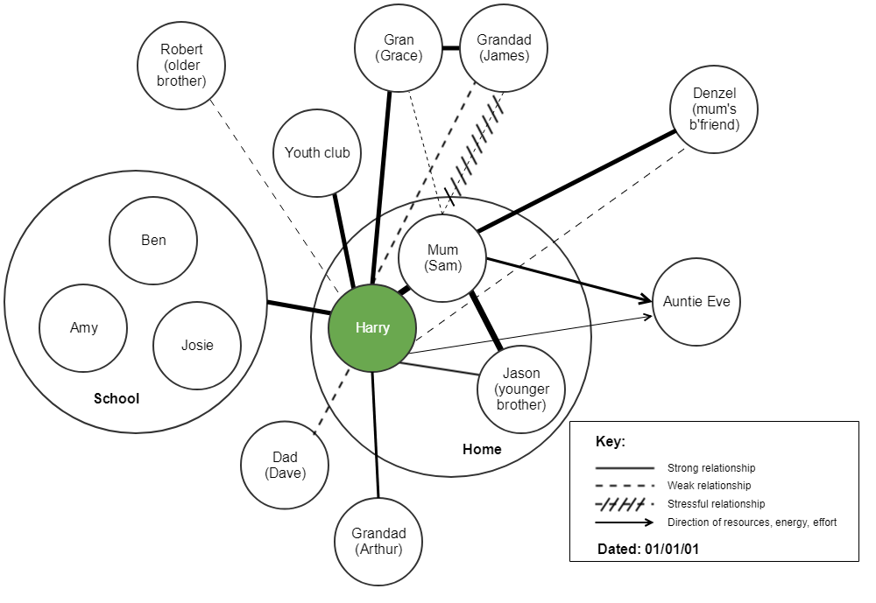

We can see that there is a lot of information that can be stored for quick access using an ecomap. There are few hard and fast rules that relate to an ecomap – these can be summarised as follows:
- Always use a large sheet of paper and ensure that the child / young person is in the centre of the paper. The exercise often works well when cut out shapes are used as these can be moved around as required before the final version is stuck down.
- The strength of relationships can be illustrated however the young person feels they want to do it. It is however important that there is a key so that the ecomap can be understood, and the key used in the example above is the generally accepted common standard.
- The distance between the different people is important as this shows how close the child / young person feels to someone.
- Date the ecomap – things change and it is useful to see when ecomaps were created as this evidences how things have changed.
Although this example is mostly black and white, colour is good. This is the child / young person’s creation and therefore we should give them as much free reign as possible as this will increase their level of ownership of the document.

